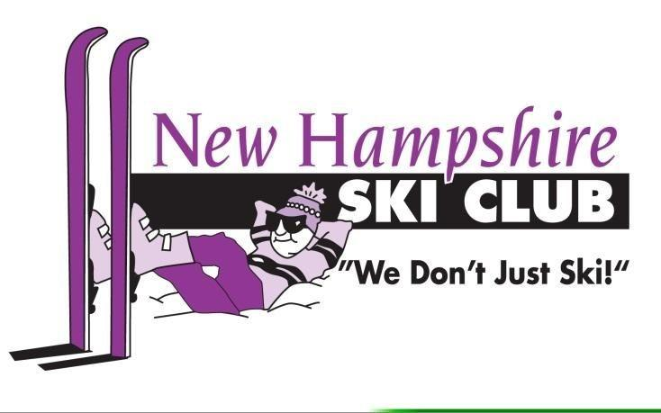 | Quebec City  Ski Trip  March 16 – 19, 2023  Bus Trip  $909.00 pp/double occupancy  $1,259.00 single occupancy
This March of 2023 - Thursday through Sunday Bus Trip offers 2 days of skiing. Quebec City opportunities other that down-hill skiing include cross-country skiing, snowshoeing, shopping, museums, visiting historic churches, a boat ride on the ferry across the river, and enjoying the pool and spa at the Chateau Frontenac.
Cancellation and refund policy: There are no refunds for the trip unless you find a replacement, then you will be reimbursed upon request. For more information review the policy: NHSC trip cancellation & refund policies on our website.
- Check box, _____ Initial & _____Date to indicate that you have read & understand the cancellation & refund policy.

- Roundtrip private motor coach throughout including pick-ups in N. Londonderry, Concord & Lincoln, NH.
N. Londonderry: Exit 5 Park & Ride at 4 Symmes Drive. Concord: Concord Trailways terminal 30 Stickney Ave. Lincoln: Woodstock/Lincoln Visitor’s Cente, directly off I-93 Exit 32, 200 Kancamagus Hwy Woodstock. Circle bus Pick-up area: N. Londonderry Concord Lincoln
- 3 nights luxury accommodations at the famous Chateau Frontenac in Historic downtown Quebec City. Luggage handling, included.
- 2 days of skiing at Mont Ste-Anne or possibly 1 day at Le Massif & 1 day at Mont Ste-Anne. TBD
- All taxes and bus driver gratuity included.
- Epic Pass including Mont Ste- Anne/Le Massif, deduct $90.00 from the final payment.
- Non-skier deducts $180.00 from final payment.
Deposit​ of $200.00, by check, due with registration beginning 9/14/2022 _______ Total payment due by 01/15/2023
Make checks payable to: NH Ski Club
Mail with completed form to: Karen Schwotzer 24 Gold Street Manchester, NH 03103
Trip Leader: Karen (Lewis) Schwotzer karenslewis@comcast.net Cell 603-289-0921
Name ___________________________________ Address:_____________________________________
City:_____________________________________ State______________ Zip:______________________
Cell phone:________________________________ Email:_______________________________________
Emergency contact:______________________ Relation:________________ Phone:__________________
Roommate (if known) ____________________________________________________________________

I, the undersigned, if accepted as a member on this trip, agree to abide by club policies and guidelines at all times during the course of this trip. I also certify, by my signature, that I am 18 years of age or older, that my name is the same as required on proof of identity and that I will be responsible for any fees incurred for a name change. I understand that club activities can be potentially hazardous, and I will not hold the New Hampshire Ski Club, the trip Leader, Board of Directors, operations director, chair people, advisors, or members responsible for any injury or damage to me, or my family members, encountered while participating in this trip.

Signature:________________________________________________________ Date:_____________

